PERSONAL INFORMATION | Vasiliki Itsiou
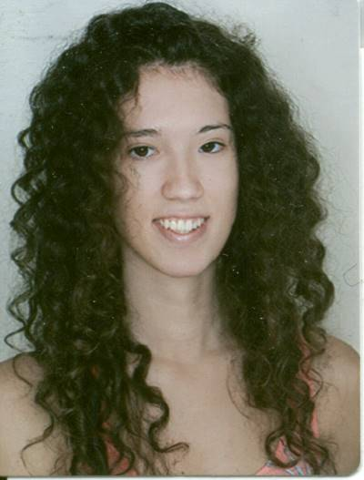 | 8,N. Kountouriotou, Thessaloniki, 56122, Thessaloniki
 | 2310738767 6943984497
 | Vaswitsiou@gmail.com
 | Sex Female | Date of birth 24/07/1997 | Nationality Greek

STUDIES | Student at the faculty of Business Administration at the Technological Educational Institute  of Thessaloniki  One semester Erasmus studies in Czech University of Life Sciences in Prague

EDUCATION AND TRAINING

2012-2015

Graduated from the 1o Lyceum of Menemeni

PERSONAL SKILLS

Mother tongue(s) | Greek
Other language(s) | UNDERSTANDING |  | SPEAKING |  | WRITING
 | Listening | Reading | Spoken interaction | Spoken production
English | C2 | C2 | C2 | C2 | c2
 | Michigan Proficiency C2.
German | C1 | C1 | C1 | C1 | C1
 | GOETHE ZERTIFIKAT C1
Russian | A2 A2 A2 A2 A2
Enter level Enter level Enter level Enter level Enter level  Replace with name of language certificate. Enter level if known. | Levels: A1/A2: Basic user - B1/B2: Independent user - C1/C2 Proficient user  Common European Framework of Reference for Languages

Communication skills | - good communication skills gained through my experience as volunteer in Santa Run Thessaloniki and other events

Organisational / managerial skills | - leadership (currently responsible for a team of 10 people when organizing the event of Santa Run)

Digital skills | SELF-ASSESSMENT
 | Information processing | Communication | Content creation | Safety | Problem solving
 | Independent user | Independent user | Independent user | Independent user | Independent user
Levels: Basic user - Independent user - Proficient user
Digital competences - Self-assessment grid
 | Replace with name of ICT-certificates
- good command of office suite (word processor, spread sheet, presentation software)
- good command of photo editing software gained as an amateur photographer

ADDITIONAL INFORMATION

Seminars  Memberships  Hobbies | Digital Marketing from Google, Risk management methodologies in Thessaloniki, Grow Tourism from Google  Scholarship from DAAD for one month studies in Germany, in Munich  I play the piano for three years and I was playing the flute as a member of the philharmonic band of the municipality of Menemeni
ANNEXES




